TOP 10 GENES

OVERVIEW :

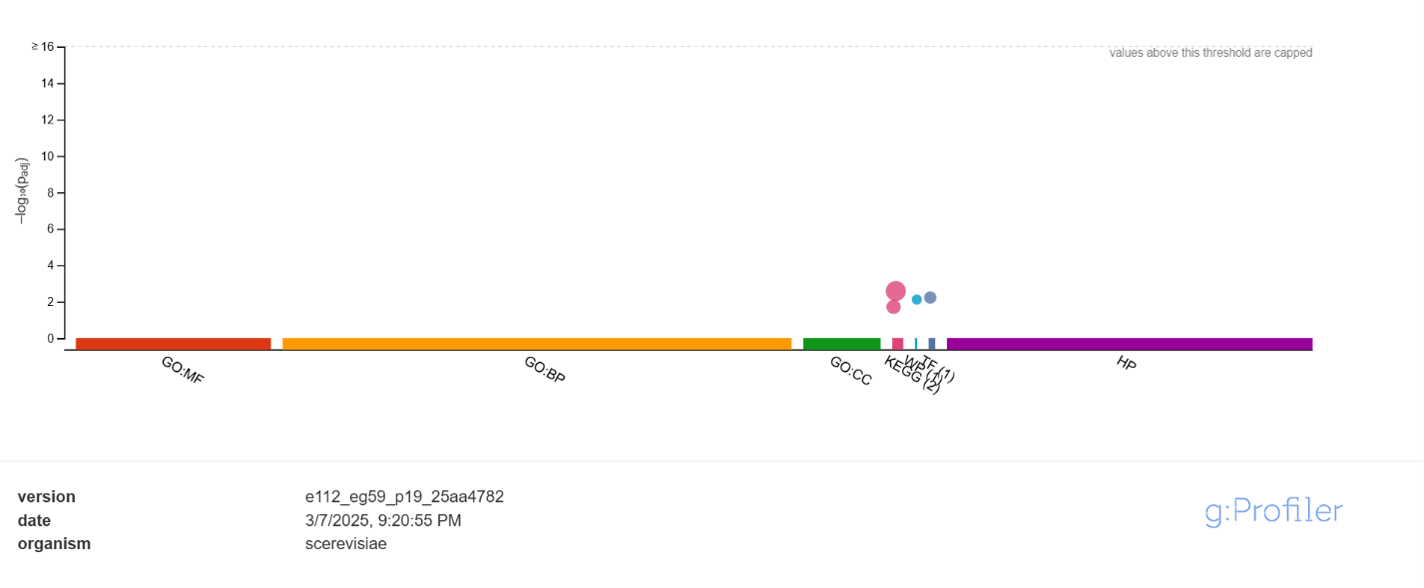

DETAILED

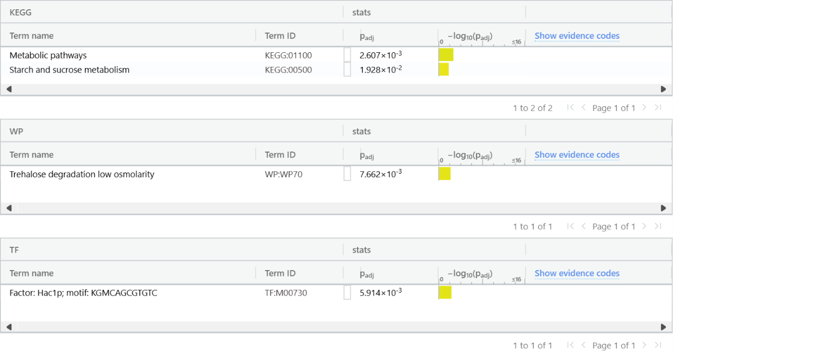

BOTTOM 10 GENES

OVERVIEW

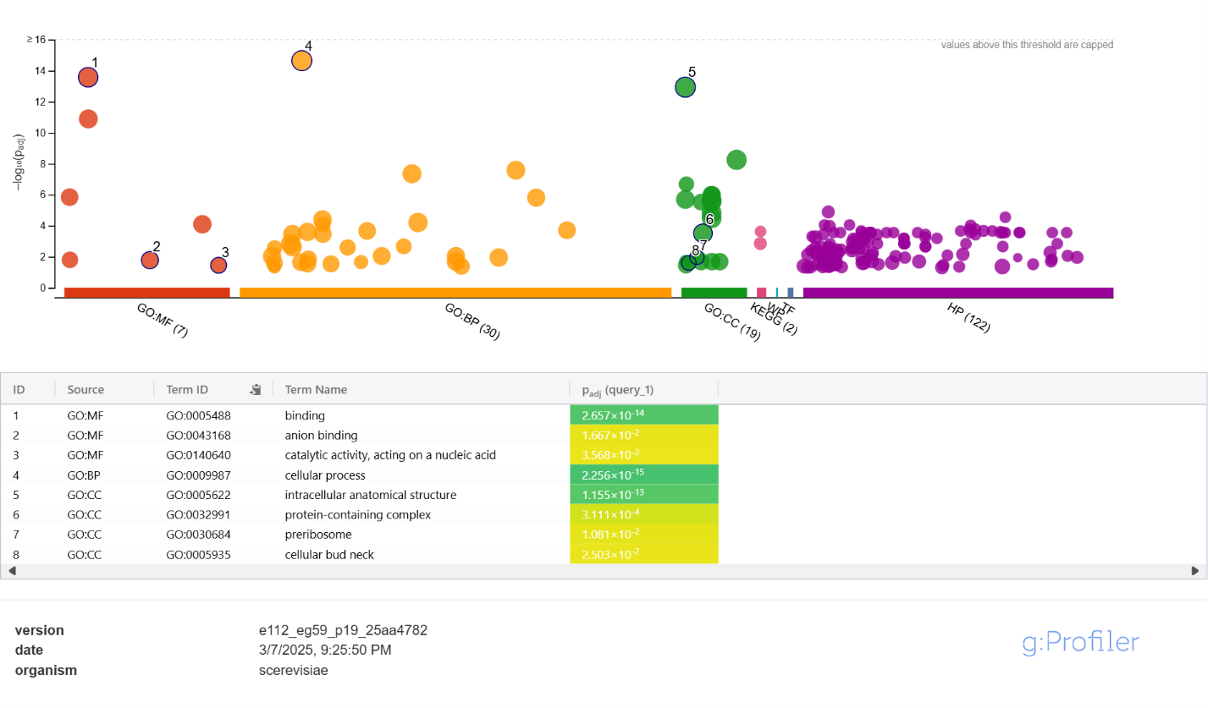

DETAILED